**APPLICANT PART**

**STEP -1:**

At first login to Service plus web portal**: (**<https://tathyasathi.bangla.gov.in/>) to apply for the **Application for Rent payment of Flats in Bidhannagar Municipal Corporation Area**

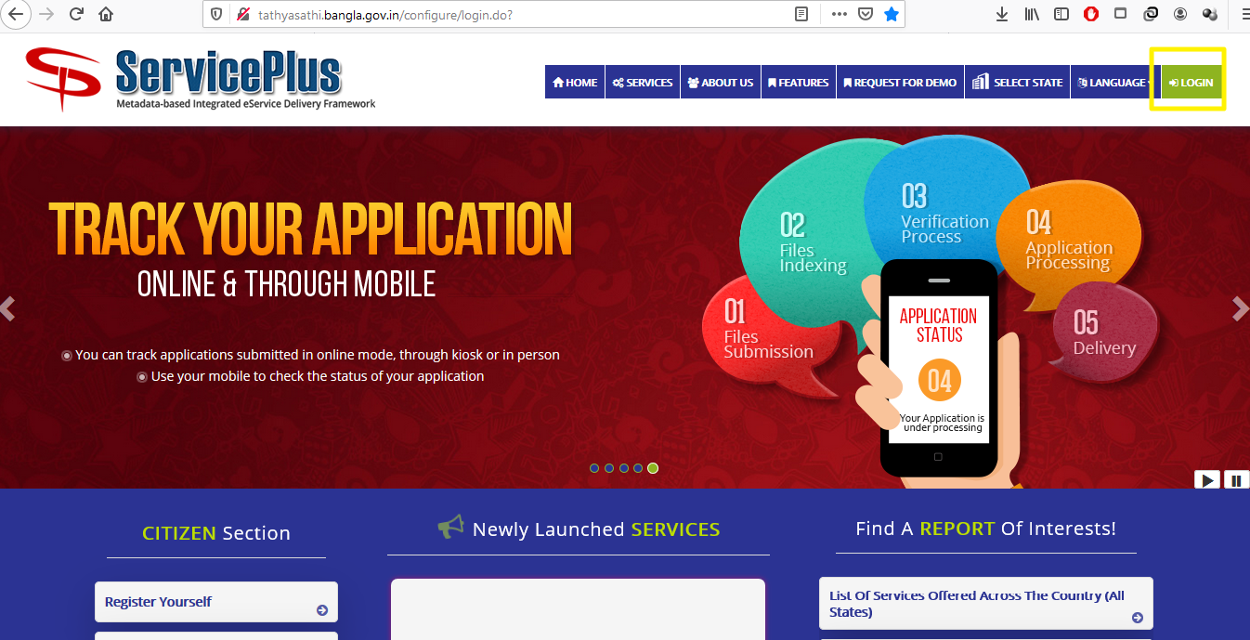

**Step -2:**

Login as Applicant in the Service plus portal.

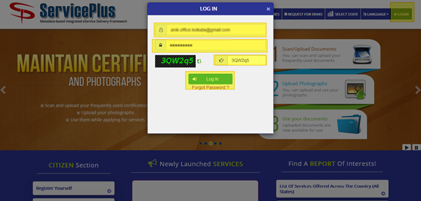

**Step -3:**

Now click “**Apply for services”** and select “**View all available services**”, then Select particular Service and Fill the form:

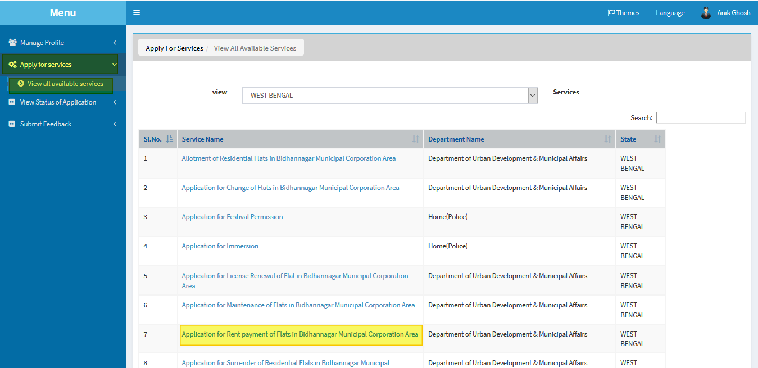

**Step -4:**

Fill the details “**Flat No**” and “**License Number**” and click **Get Data.**

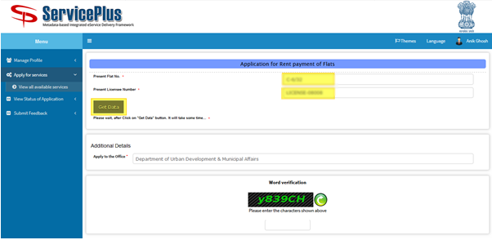

**Step -5:**

Fill the form with the details.

Do fill the **latest payment detail** with appropriate detail such as “**payment plan”** you can select in monthly, quarterly and half yearly.

After that submit by matching the captcha.

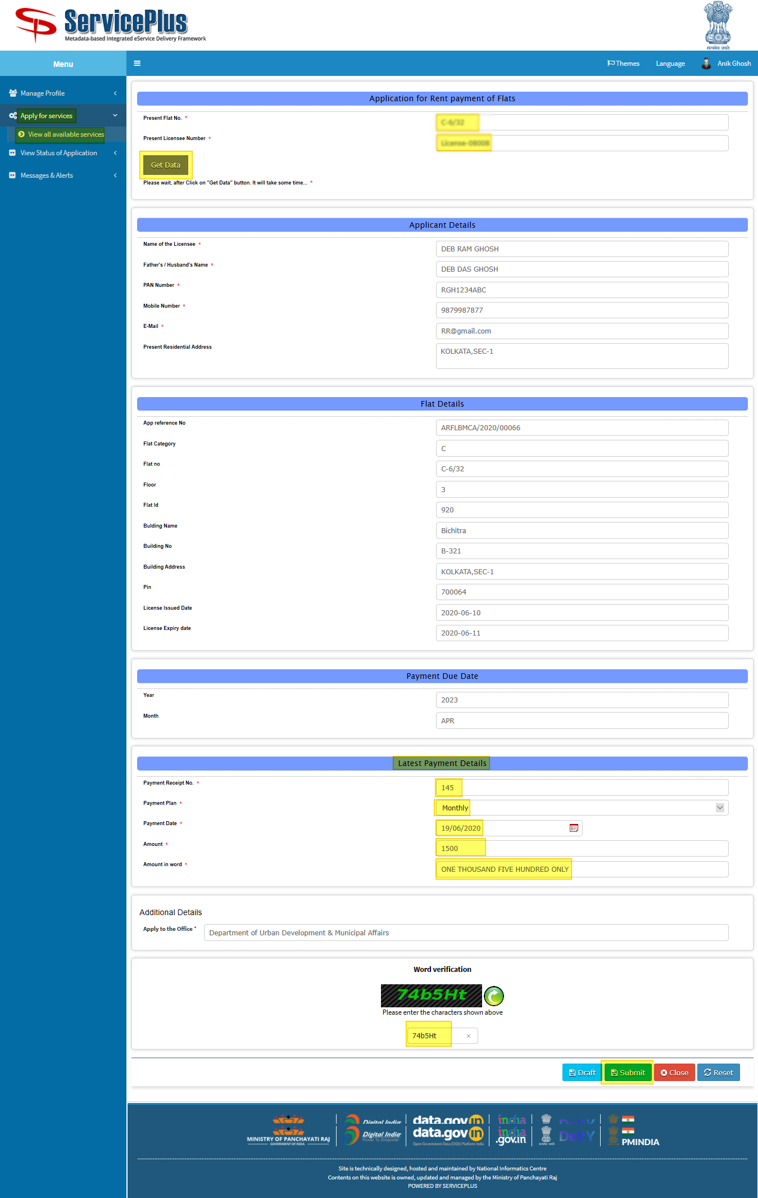

**Step -6:**

Now click “**Attach Annexure**” to attach your provided document.

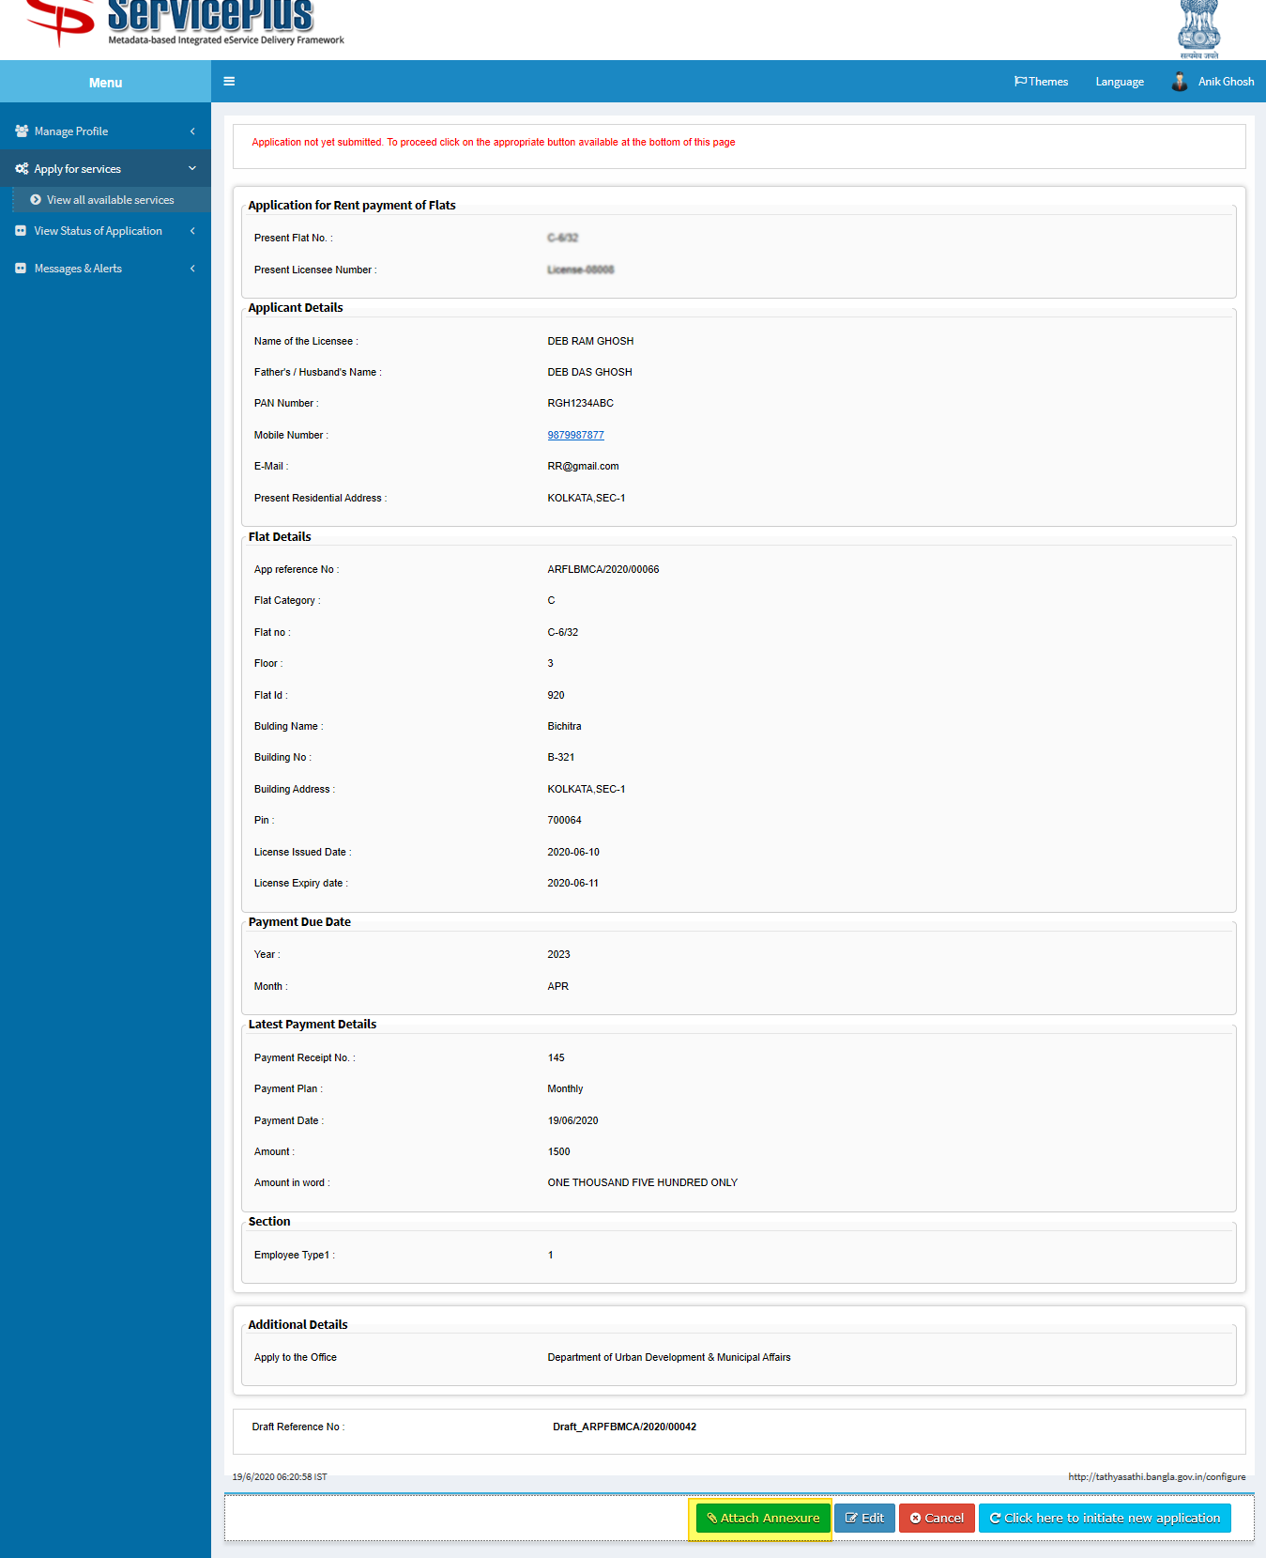

**Step -7:**

Now select the appropriate annexure and click on “**save annexure”**.

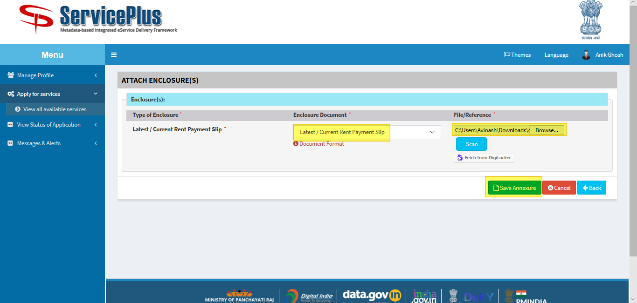

**Step -8:**

Now go through the form and click **submit** for applying.

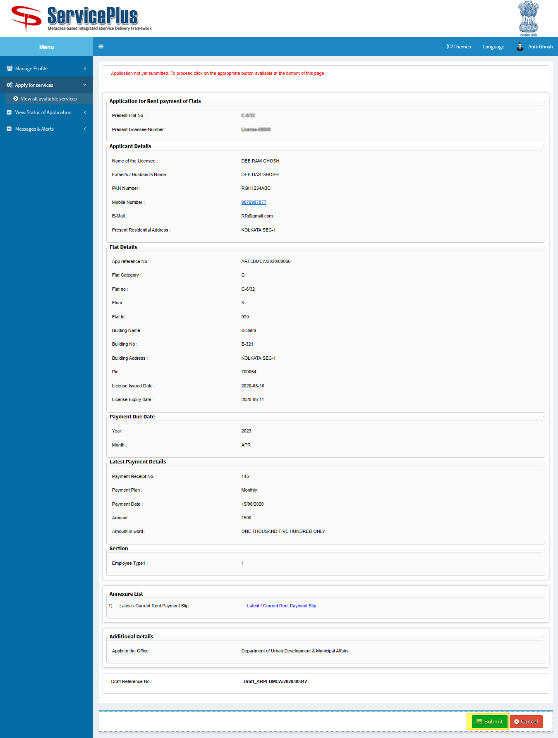

**Step -9:**

After Submission of form an acknowledgement slip is generated with **app reference number.**

Save by selecting “**Export to pdf”** or print it by selecting “**Print”**

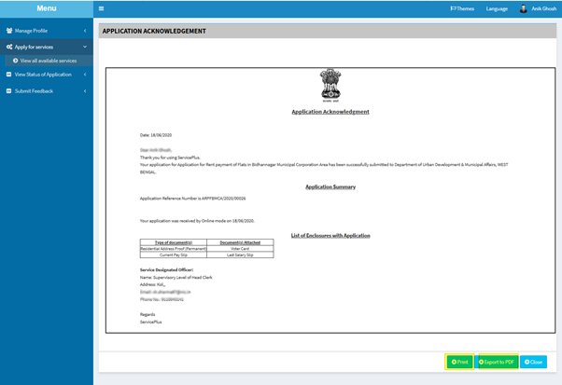

**TRACKING OF APPLICATION**

**Step -1:**

To Track the application we can select “**View Status of Application”** and go to “**Track application status”.**

Here select the appropriate date from to when and it’s optional to give “**app ref no”** to “**get data”.**

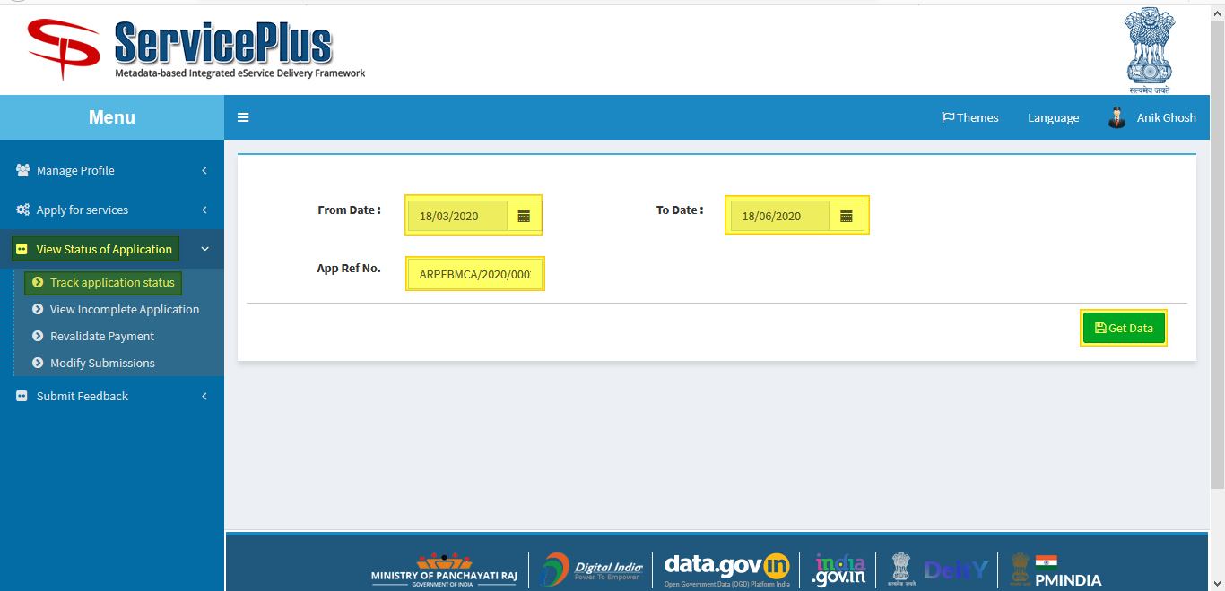

**Step -2:**

Now by getting the application select **“current status”** of the application to keep the track of status of application.

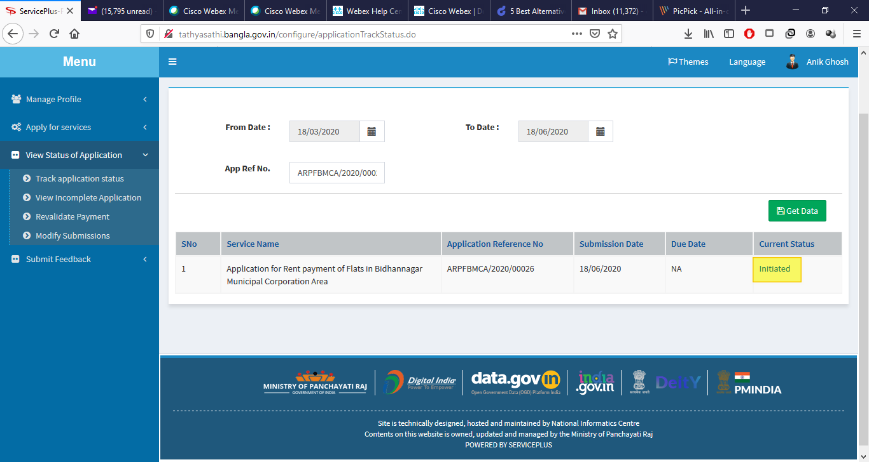

**Step -3:**

Here the application could be viewed and status could be seen of the application.

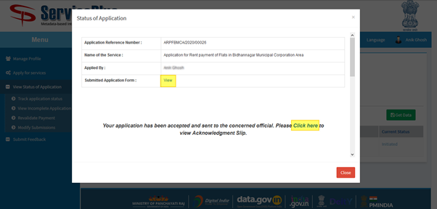

**SHORTFALL OF APPLICATION**

**Step -1:**

To Track the application we can select “**View Status of Application”** and go to “**Track application status”.**

Here select the appropriate date from to when and it’s optional to give “**app ref no”** to “**get data”.**



**Step -2:**

Select “**Waiting For Applicant’s Request”** .

A popup will open.

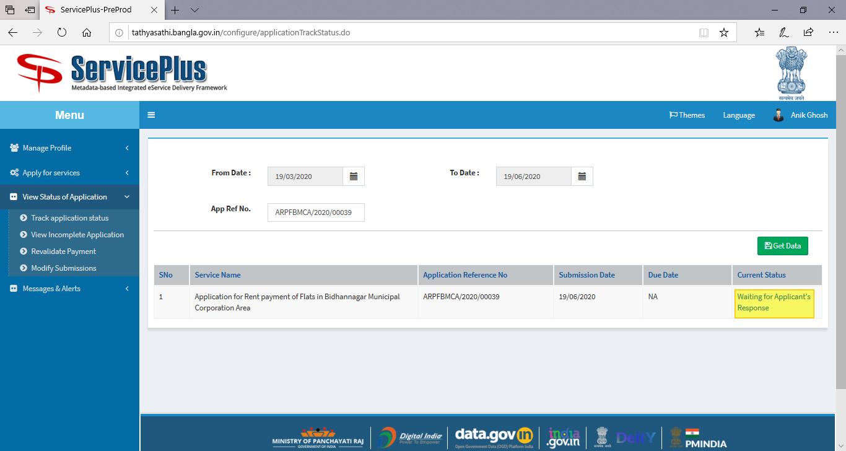

**Step -3:**

Select **click here** to re attach your attachment.

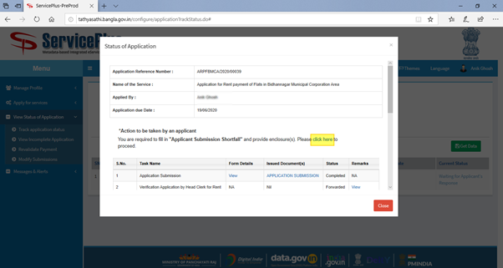

**Step -4:**

Give Remarks and click **submit.**

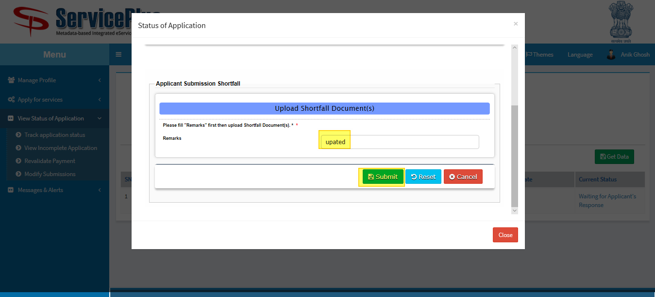

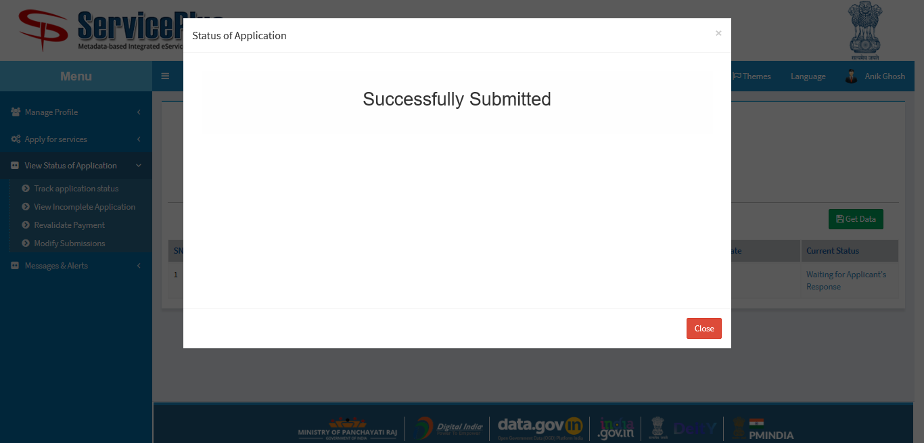

**Step -5:**

Attach the appropriate attachment and click **submit.**

